

**CHEMICAL INFORMATION MANAGEMENT SYSTEM C.I.M.S**

User Manual

(Enforcement Officer)

**DEPARTMENT OF OCCUPATIONAL SAFETY AND HEALTH (DOSH) MARCH 2011**

**User Manual for Enforcement Officer Module**

Chemical Information Management System

Department of Occupational Safety and Health Malaysia

**CONTENTS**

**USER MANUAL FOR ENFORCEMENT OFFICER MODULE......................................................... 2**

CHEMICAL INFORMATION MANAGEMENT SYSTEM ................................................................................. 2

**MAIN SCREEN...................................................................................................................................... 3**

**LOGIN.................................................................................................................................................... 3**

**HOME .................................................................................................................................................... 4**

NEW CHEMICAL ....................................................................................................................................... 5

**INVENTORY ......................................................................................................................................... 6**

SUB MENU ........................................................................................................................................... 6

ACTIVITY BUTTON................................................................................................................................ 6

CHEMICAL LIST ......................................................................................................................................... 7

SYNONYM LIST..................................................................................................................................... 8

CLASSIFIED CHEMICALS .............................................................................................................................. 9

UNCLASSIFIED CHEMICALS ........................................................................................................................ 10

**SUBMISSION....................................................................................................................................... 11**

SUB MENU ......................................................................................................................................... 11

ACTIVITY BUTTON.............................................................................................................................. 11

NEW SUBMISSION: ACKNOWLEDGE LIST ....................................................................................................... 12

RENEWAL SUBMISSION: ACKNOWLEDGE LIST ................................................................................................. 13

**REPORT............................................................................................................................................... 15**

**PROFILE.............................................................................................................................................. 16**

**Main screen**

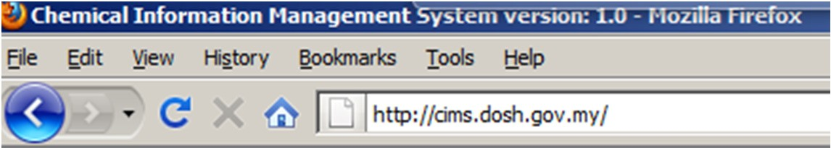

Web address: <http://cims.dosh.gov.my>

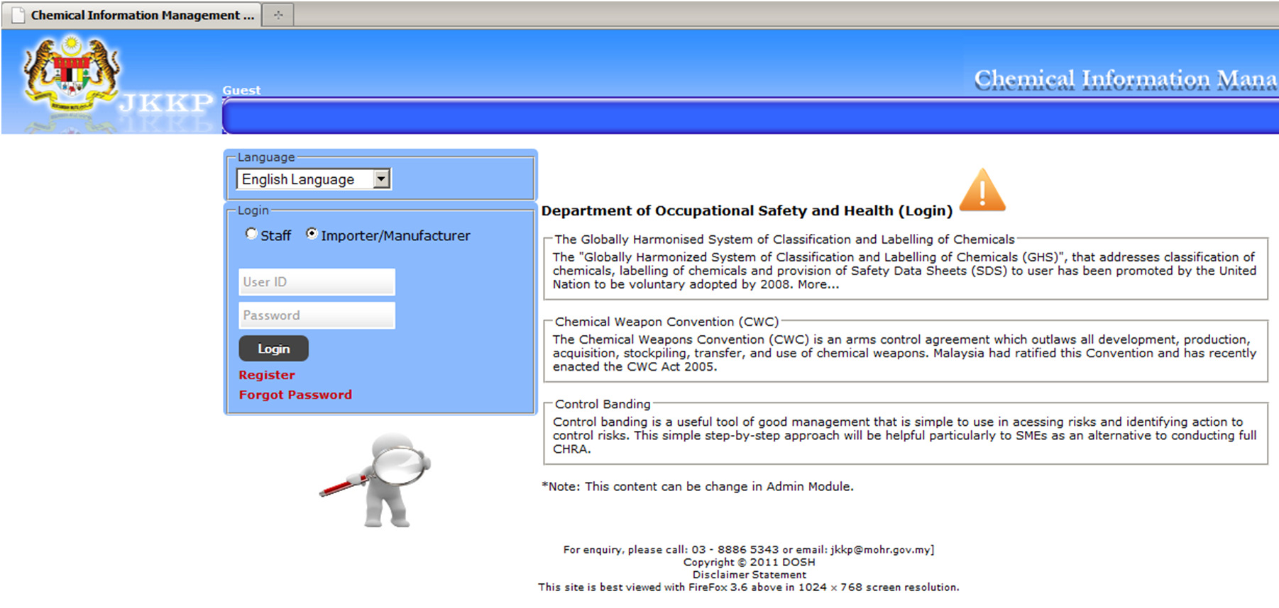

Home screen

**Login**

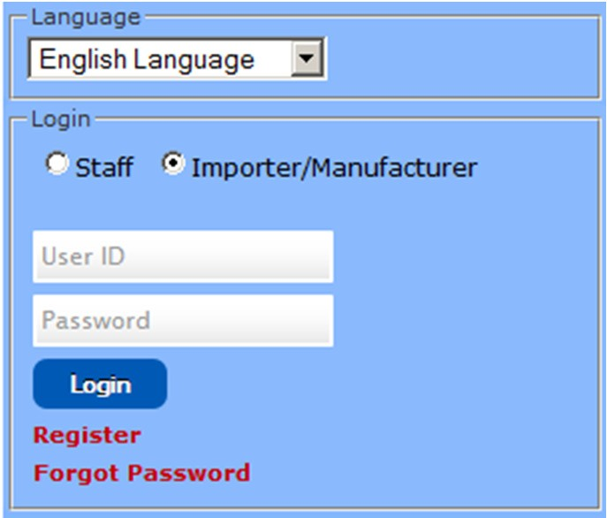

**Home**

Home screen for Enforcement Officer

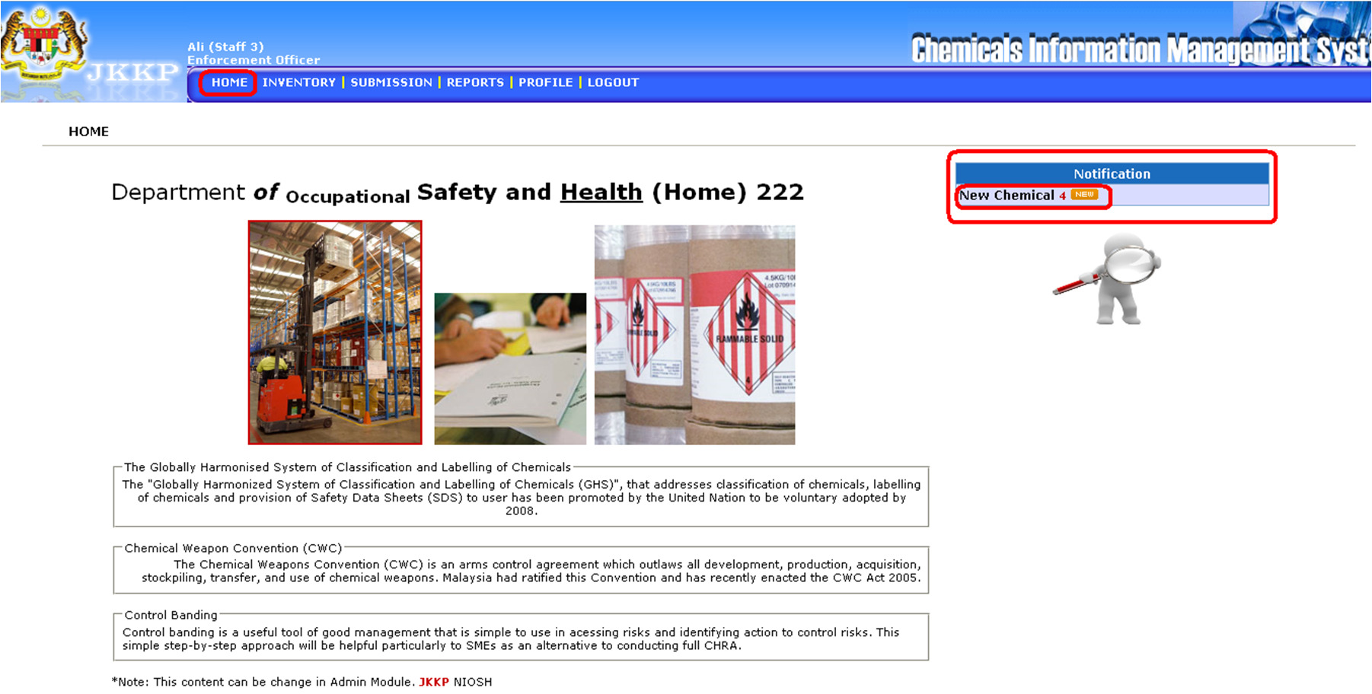

Notification shortcut for submission.

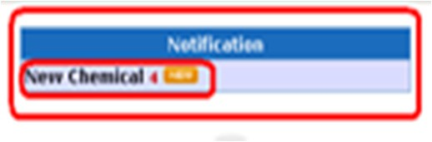

Search chemical information



***New Chemical***

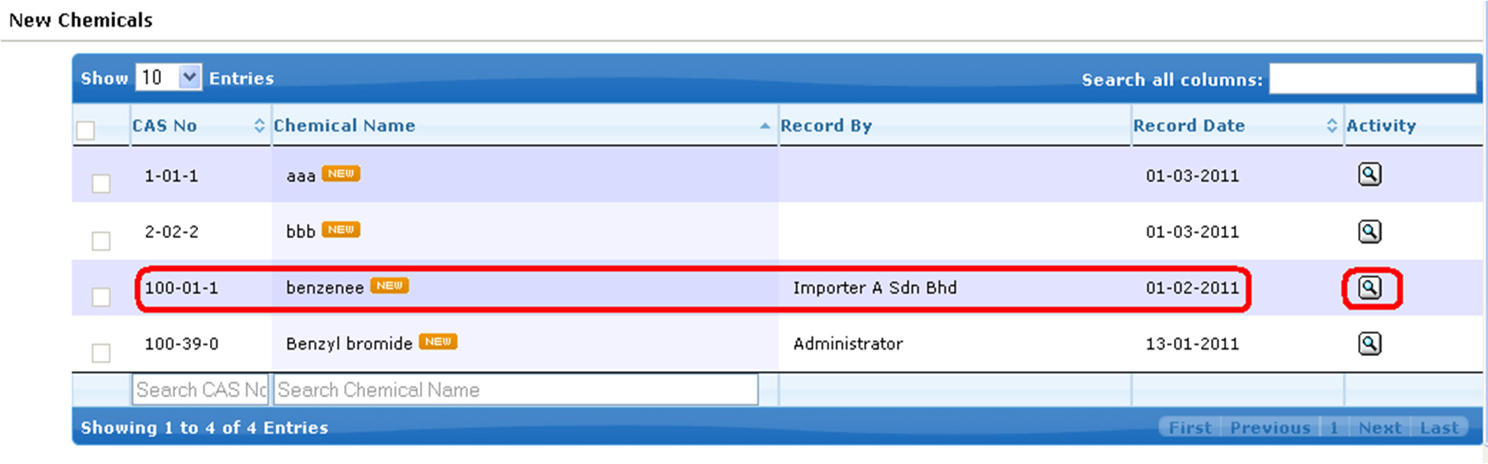

• List of new chemical

• Click View button

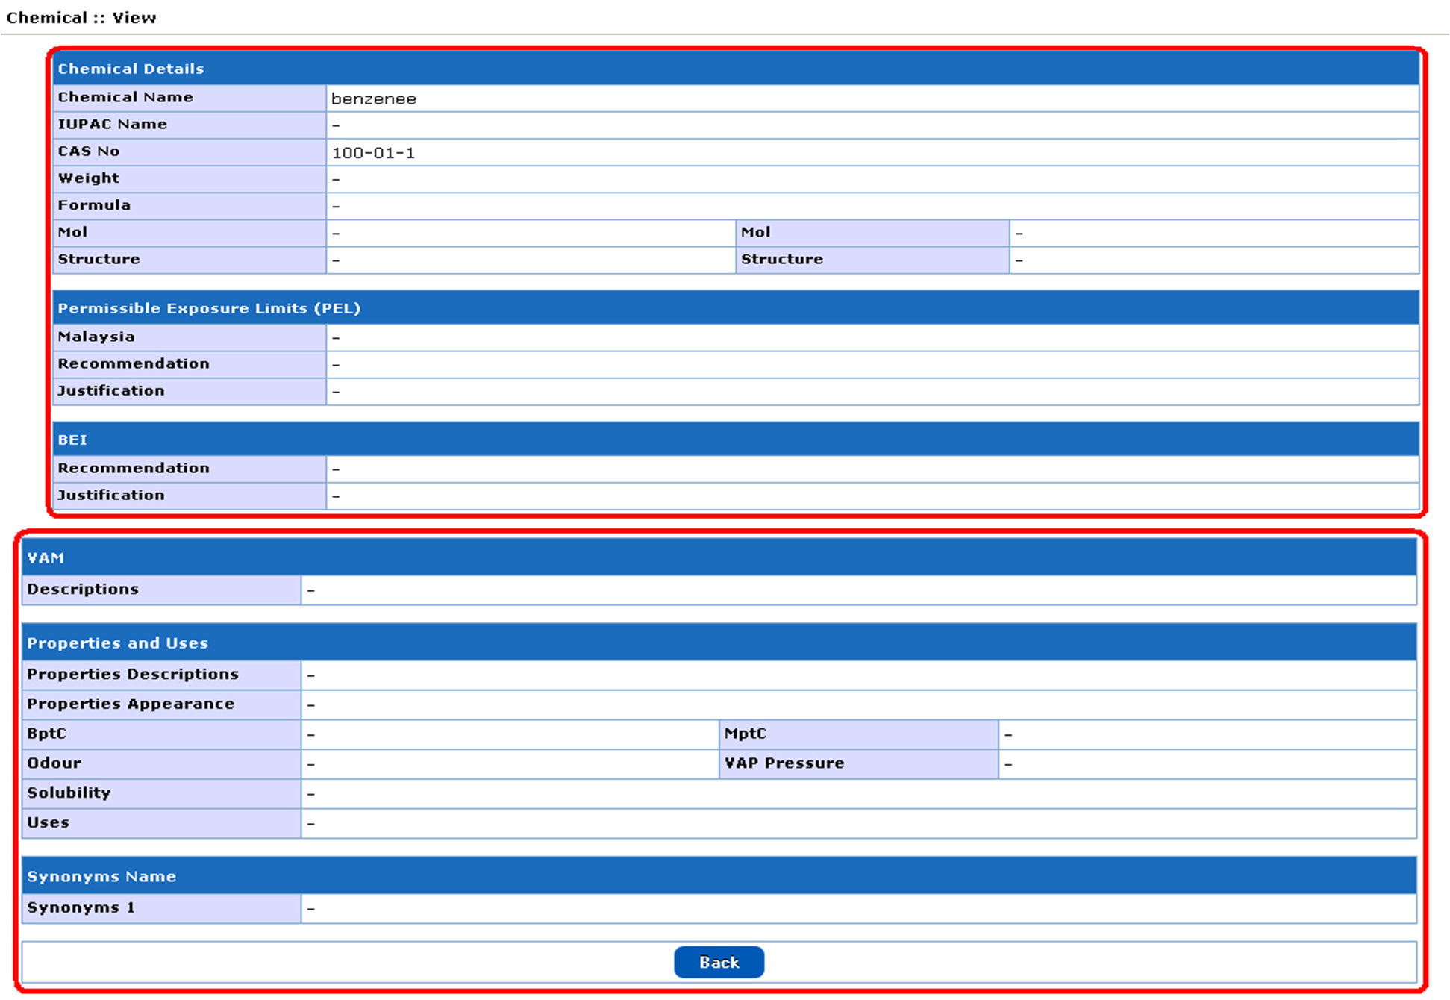

• View of new chemical

**Inventory**

Inventory sub menu

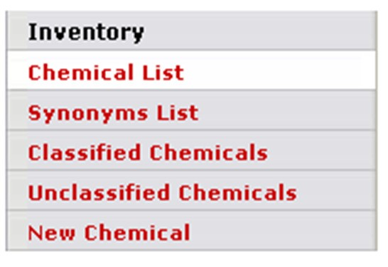

***Sub Menu***

|  |  |  |
| --- | --- | --- |
| **No** | **Menu button** | **Descriptions** |
| **Inventory** | | |
| 1 | Chemical List | List all chemical list |
| 2 | Synonym List | List all synonym list |
| 3 | Classified Chemicals | List all classified chemicals |
| 4 | Unclassified Chemicals | List all unclassified chemicals |
| 5 | New Chemical | List all new chemical |

***Activity Button***

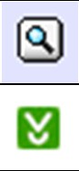

|  |  |  |
| --- | --- | --- |
| **No** | **Button** | **Descriptions** |
| 1 |  | View record details |
| 2 |  | Download records/certificate |

***Chemical List***

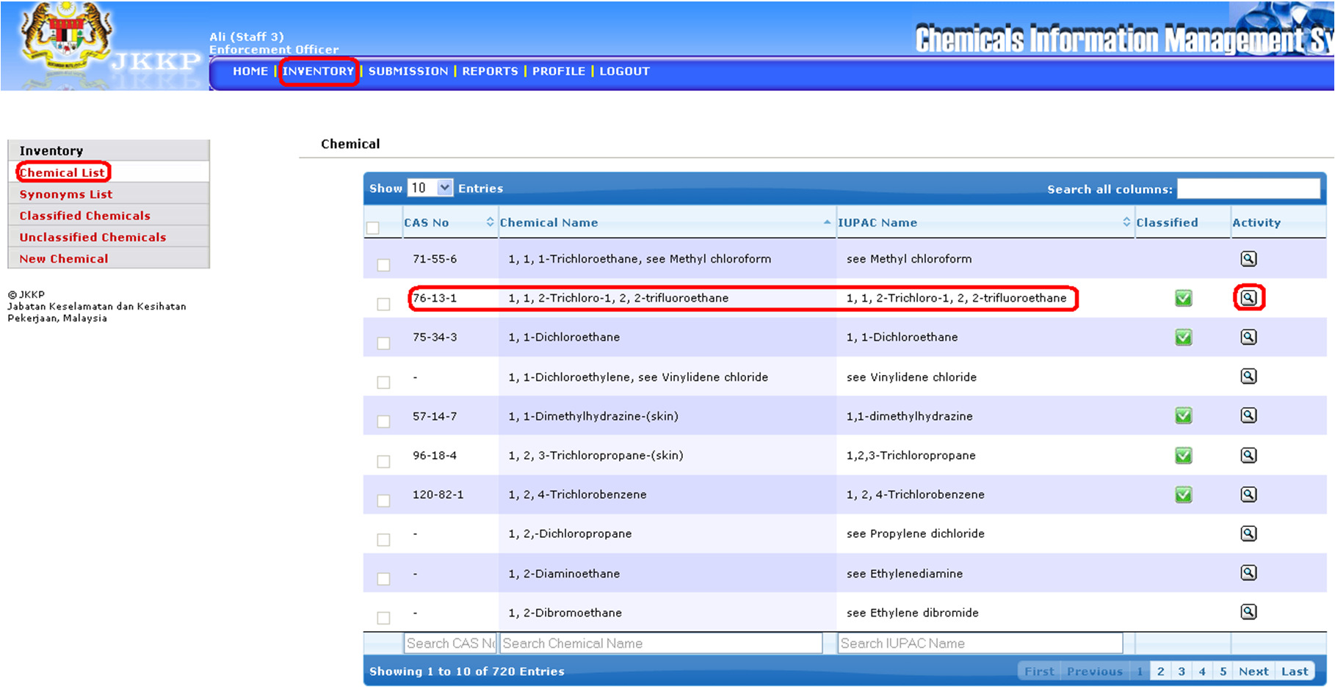

• List of chemical

• Click View button

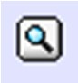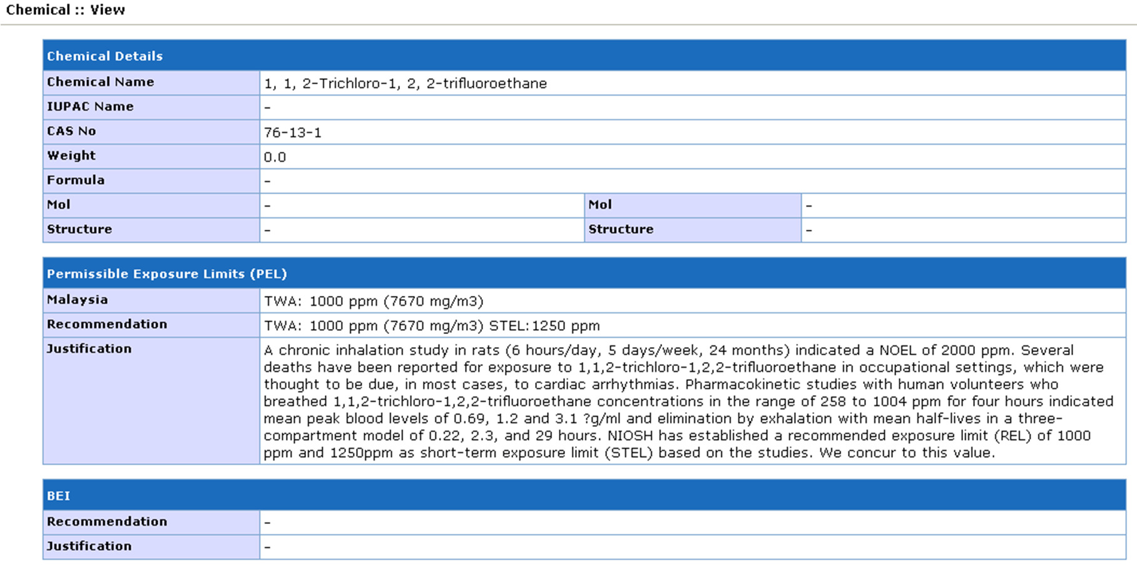

• View of chemicals list

***Synonym List***

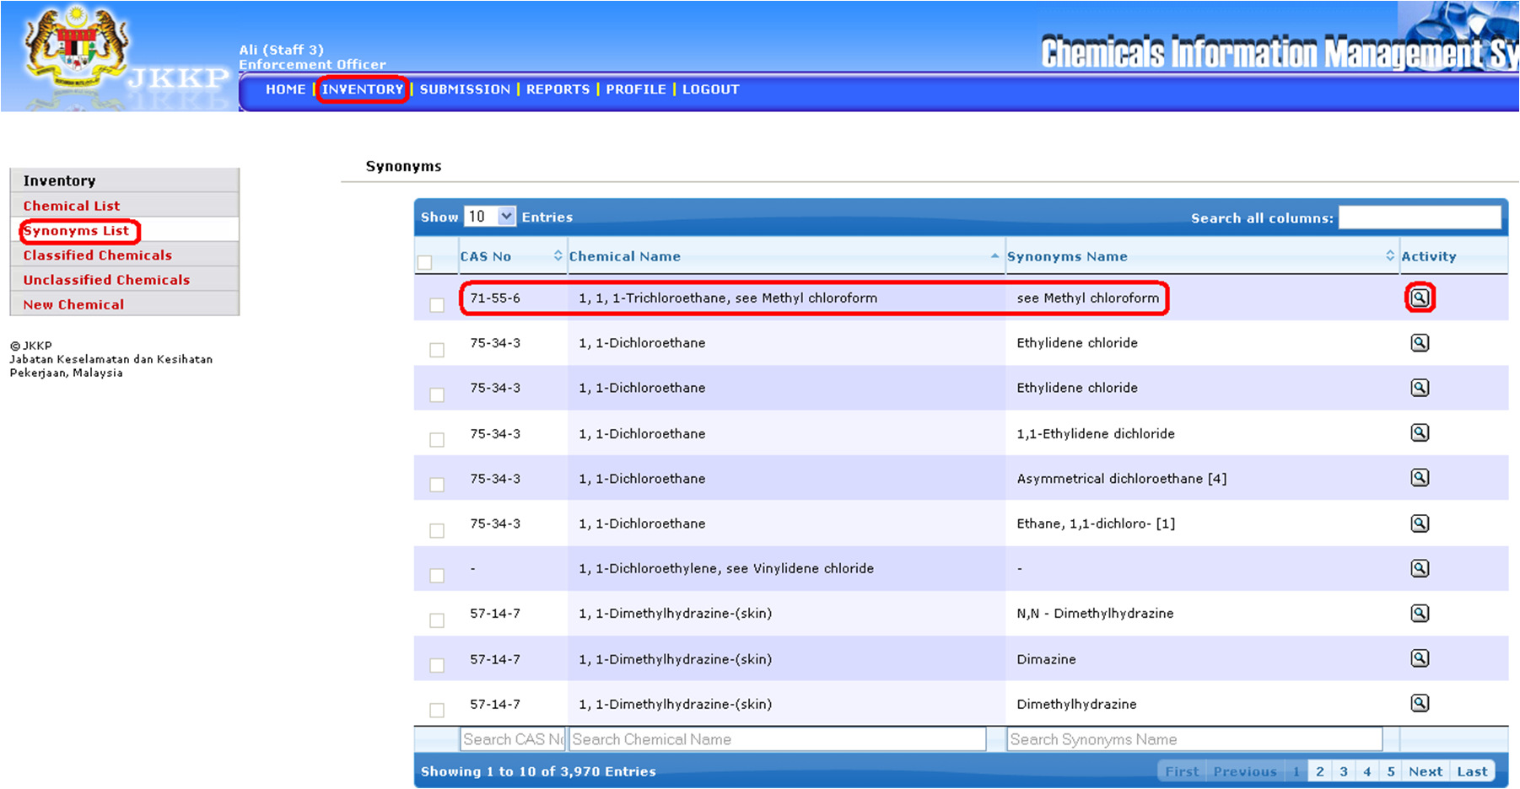

• List of synonym chemical name

• Click View button

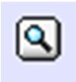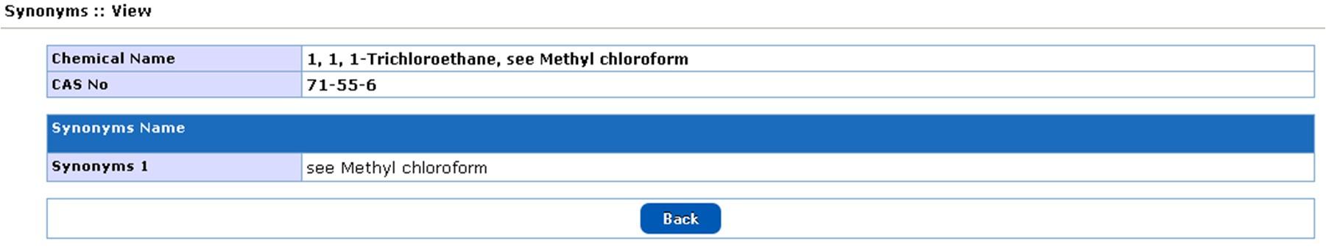

• View of synonym name

***Classified Chemicals***

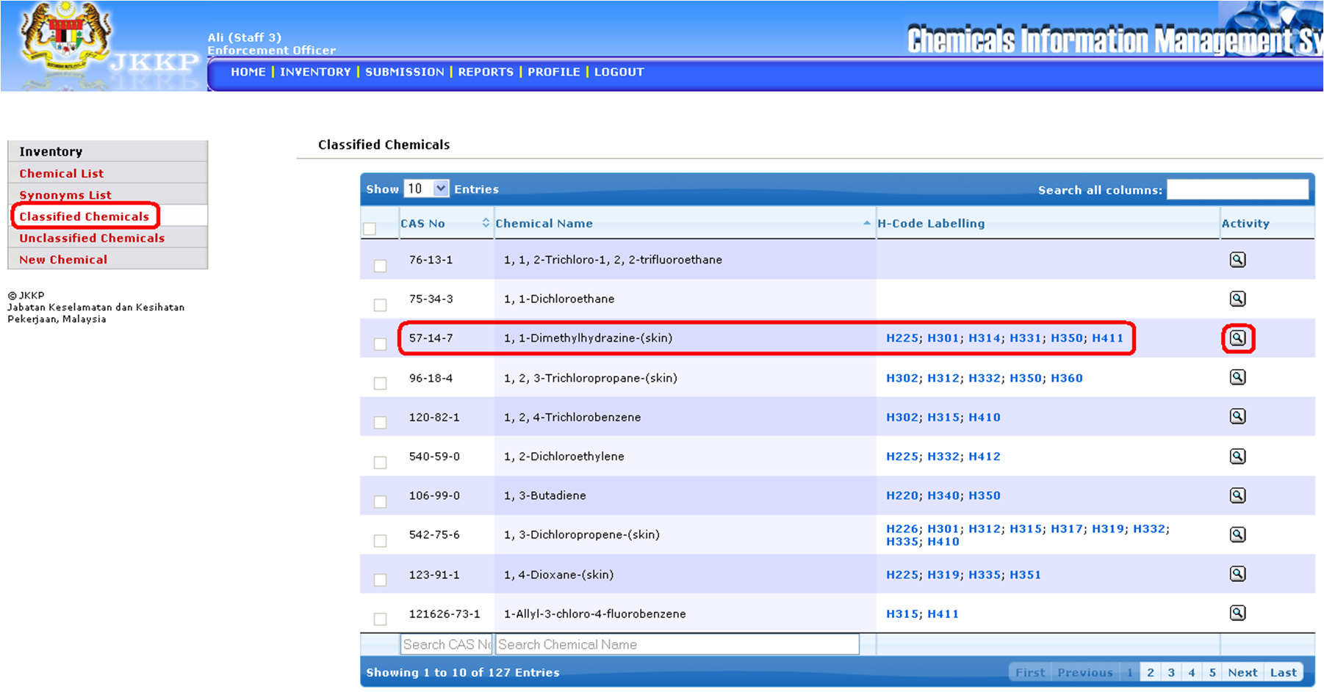

• List of classified chemicals

• Click View button

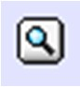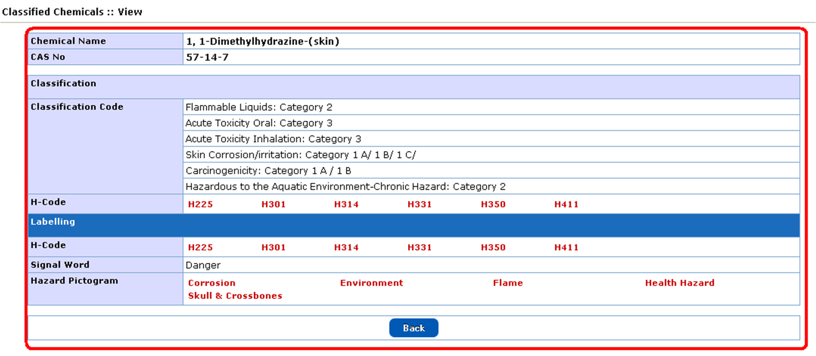

• View of classified chemicals

***Unclassified Chemicals***

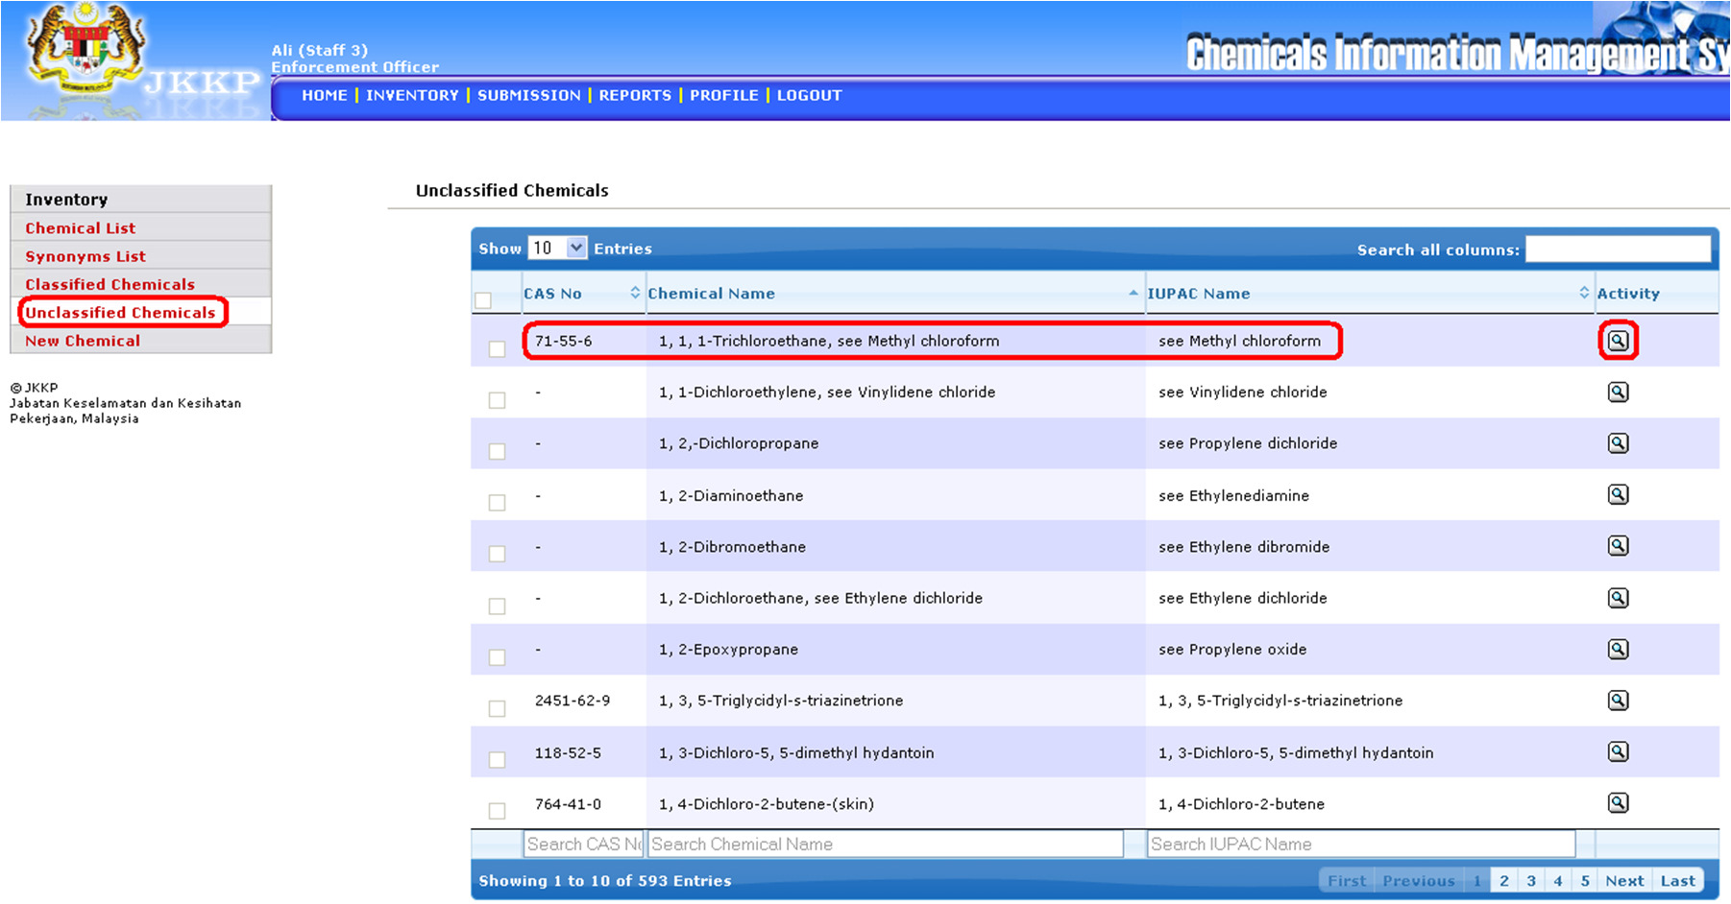

• List of unclassified chemicals

• Click View button

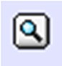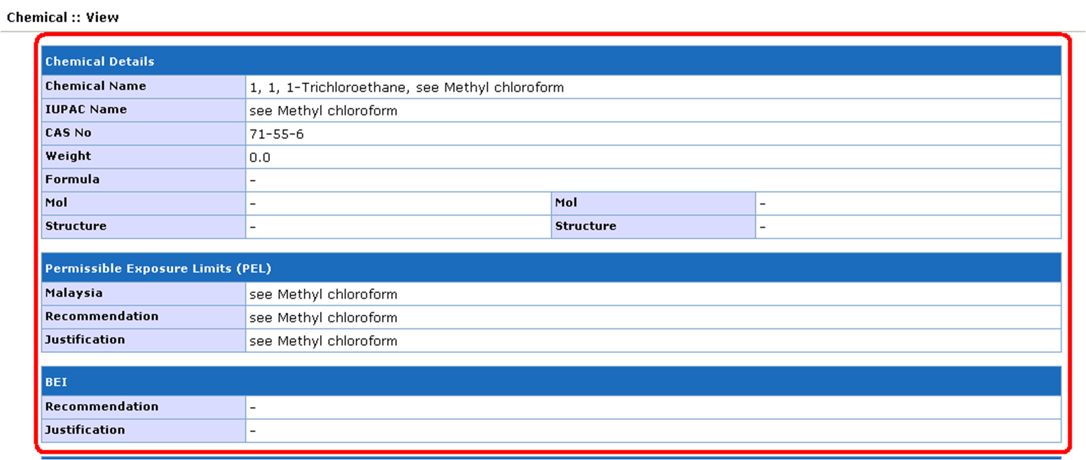

• View of unclassified chemicals details

**Submission**

Submission sub menu

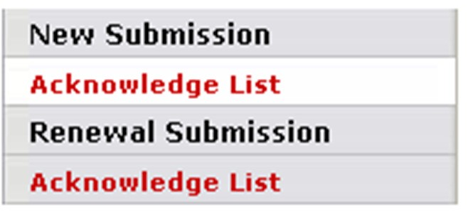

***Sub Menu***

|  |  |  |
| --- | --- | --- |
| **No** | **Menu button** | **Descriptions** |
| **New Submission** | | |
| 1 | Acknowledge List | List all acknowledge submission |
| **Renewal Submission** | | |
| 2 | Acknowledge List | List all acknowledge submission |

***Activity Button***

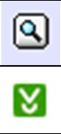

|  |  |  |
| --- | --- | --- |
| **No** | **Button** | **Descriptions** |
| 1 |  | View record details |
| 2 |  | Download records/certificate |

***New Submission: Acknowledge List***

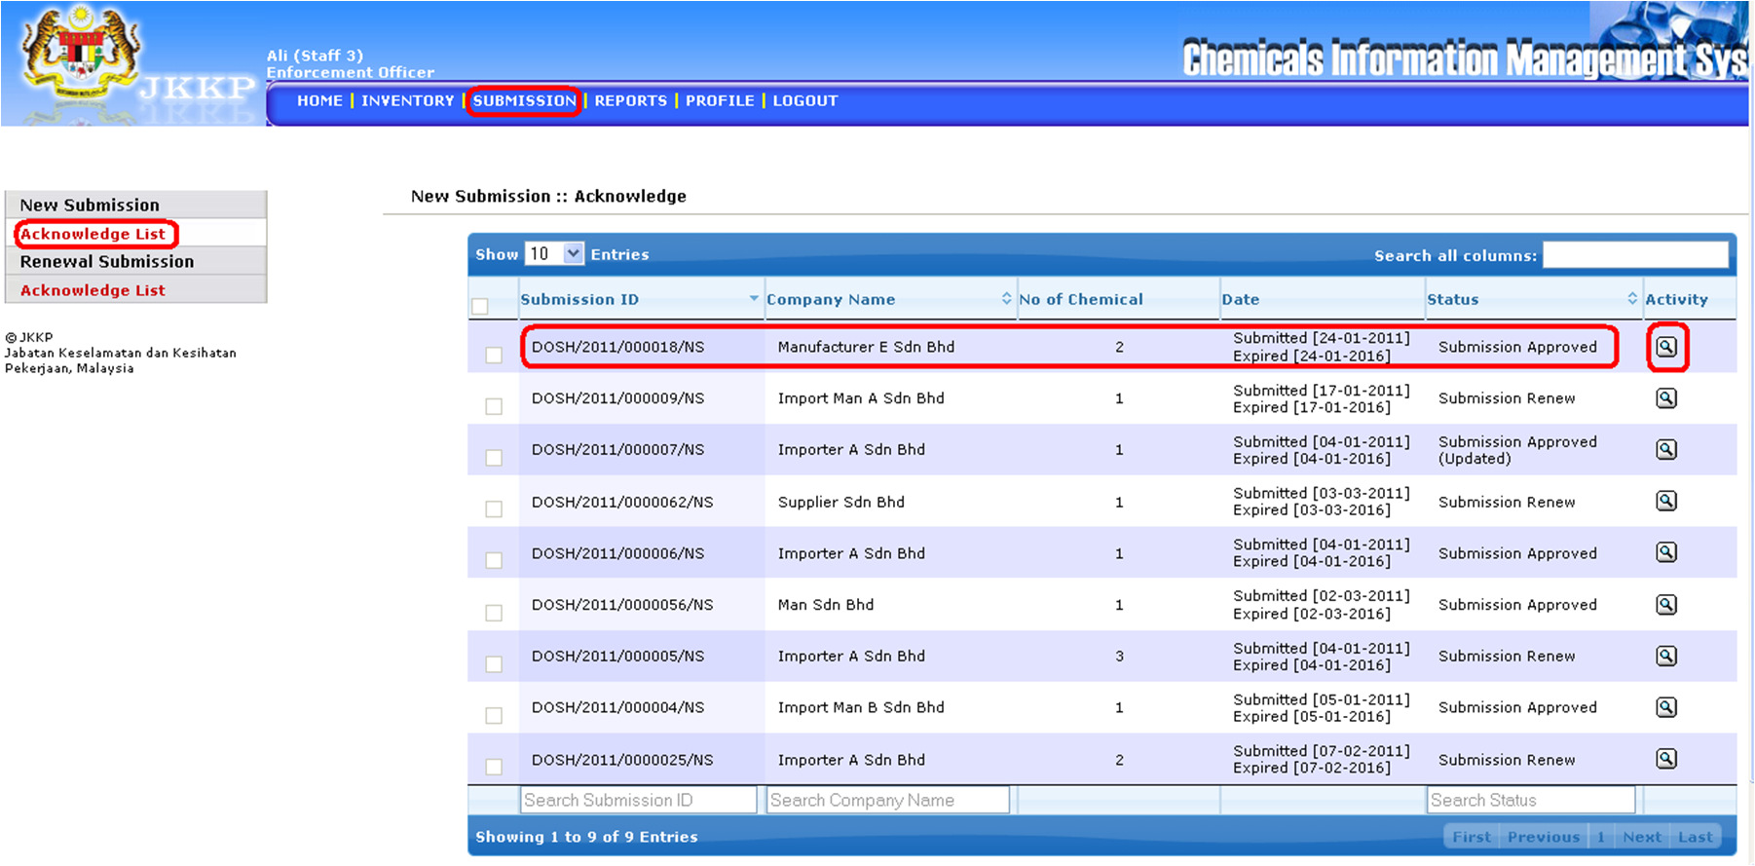

• List of acknowledge new submission

• Click View button

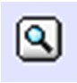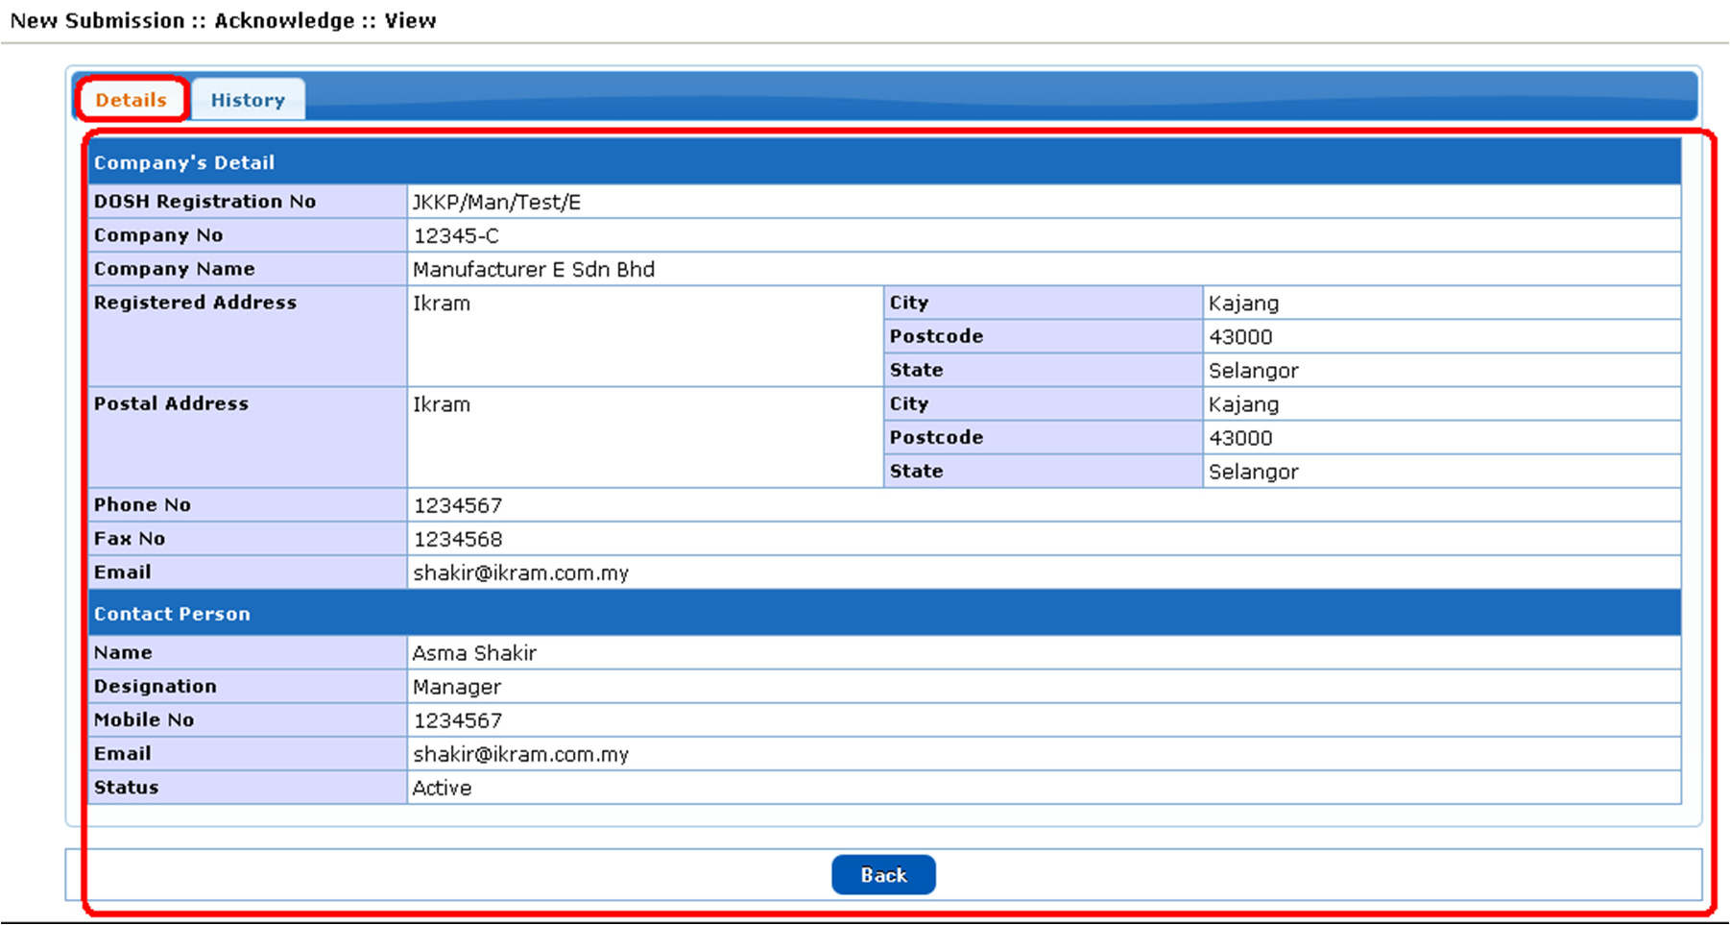

• Details of acknowledge new submission

• History of acknowledge new submission

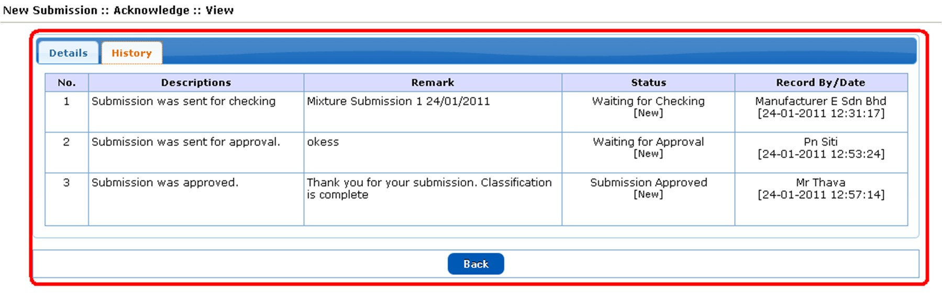

***Renewal Submission: Acknowledge List***

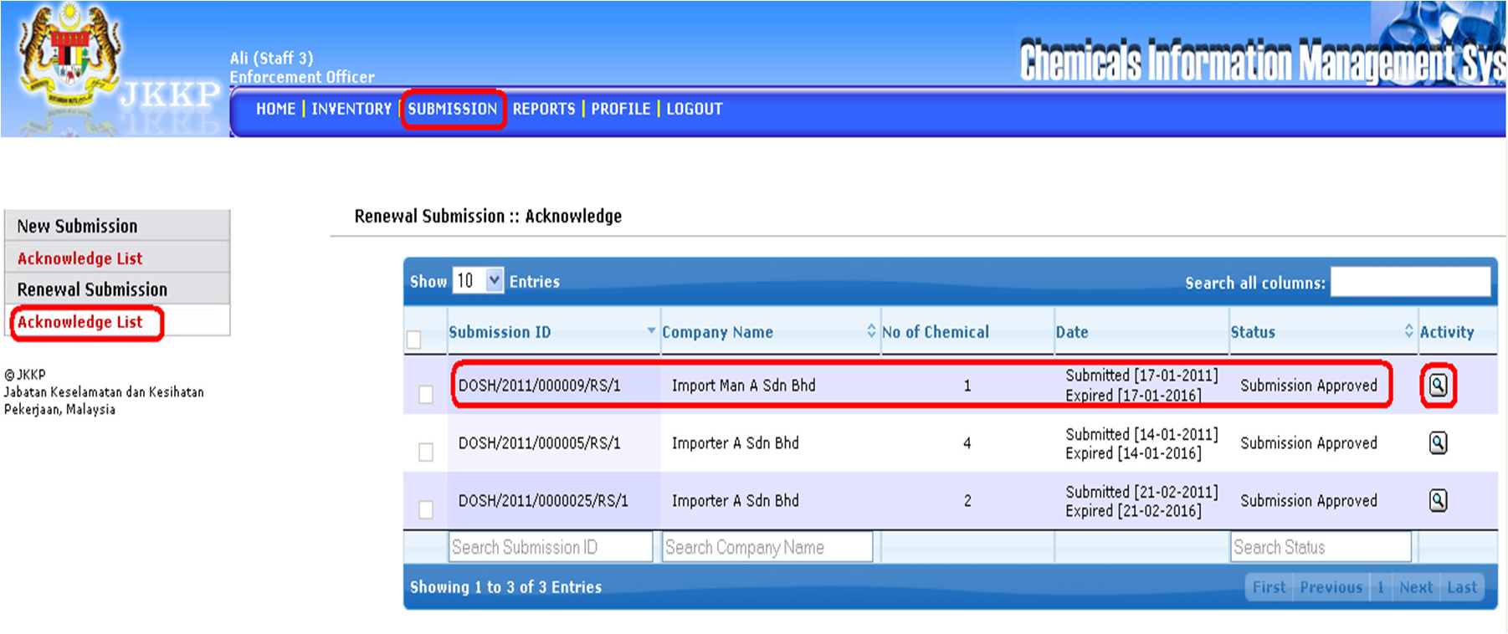

• List of acknowledge renewal submission

• Click View button

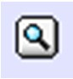

• Details of acknowledge renewal submission

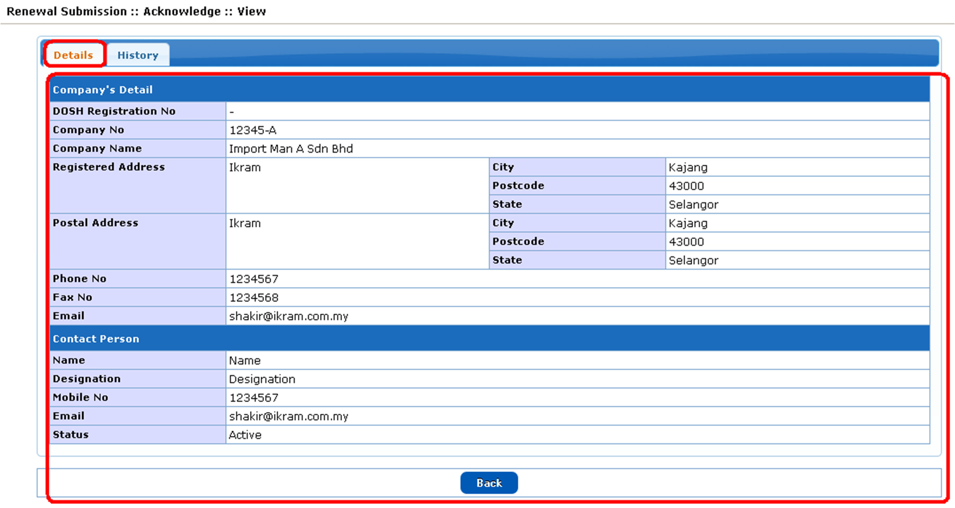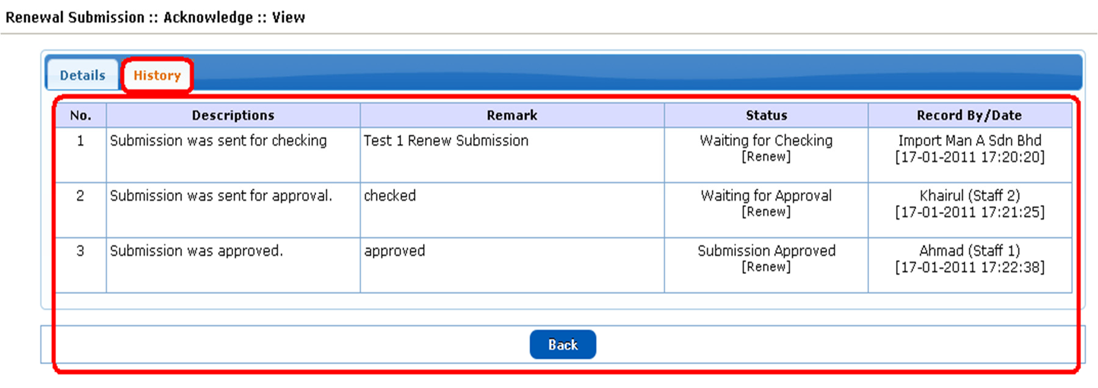

• History of acknowledge renewal submission

**Report**

Report sub menu

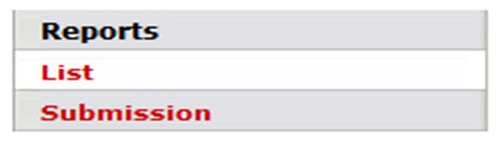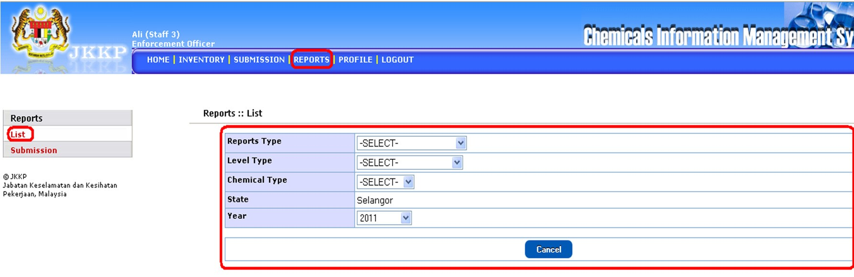

• Select report type, level type, chemical type, state and year. Click submit button when complete.

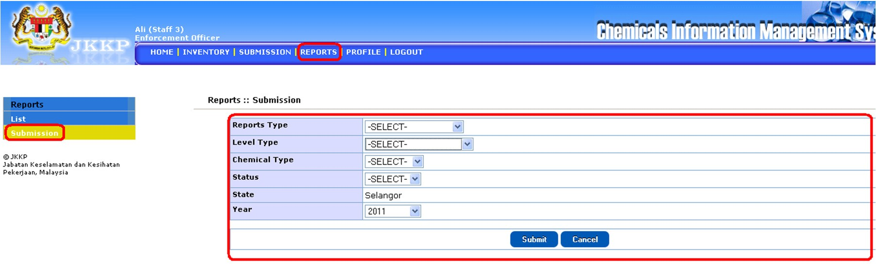

• Select report type, level type, chemical type, status, state and year. Click submit button when complete.

**Profile**

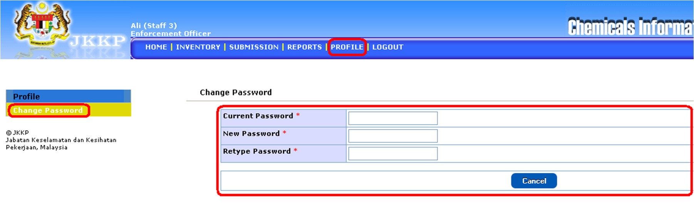

• Change password (if required).